**Genetic Algorithms**

Genetic Algorithms are search and optimization techniques based on Darwin’s Principle of Natural Selection. It is a heuristic search method used in artificial intelligence and computing. It is used for finding optimized solutions to search problems based on the theory of natural selection and evolutionary biology. Genetic algorithms are excellent for searching through large and complex data sets.

Principle of Natural Selection:

“Select The Best, Discard The Rest”

**Genetic Algorithm**

Step 1: Encoding of the problem

Step 2: Random generation of a population

Step 3: Calculate fitness of each solution

Step 4: Select pairs of parent strings based on fitness

Step 5: Generate new string with crossover and mutation until a new population has been produced.

**Encoding**

The process of representing the solution in the form of a string.

**Binary Encoding** – Every chromosome is a string of bits, 0 or 1



**Permutation Encoding** – Every chromosome is a string of numbers, which represents the number in the sequence. Used in ordering problems.

Ex: Traveling Sales Person Problem Encoding: Chromosome represents the order of cities, in which the salesman will visit them.

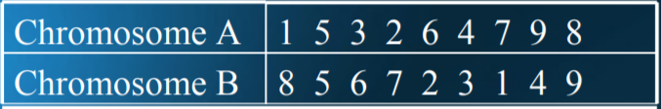

**A fitness function**

A fitness function quantifies the optimality of a solution (chromosome) so that that particular solution may be ranked against all the other solutions.

• A fitness value is assigned to each solution depending on how close it actually is to solving the problem.

Example. In TSP, f(x) is sum of distances between the cities in solution. The lesser the value, the fitter the solution is.

**Operators of GA**

Three Basic operators: **1. Selection (Reproduction) 2. Crossover 3. Mutation**

**Selection:** Chromosomes are selected from the population to be parents to crossover and produce offspring. Parents are selected according to their fitness.

**Crossover:** It is the process in which two chromosomes (strings) combine their genetic material (bits) to produce a new offspring which possesses both their characteristics.

It is applied to create a better string. Crossover MAY NOT ALWAYS yield a better or good solution. Since parents are good, probability of the child being good is high. If offspring is not good, it will be removed in the next iteration during “Selection”.

**Crossover Methods**

**Single Point Crossover**- A random point is chosen on the individual chromosomes (strings) and the genetic material is exchanged at this point

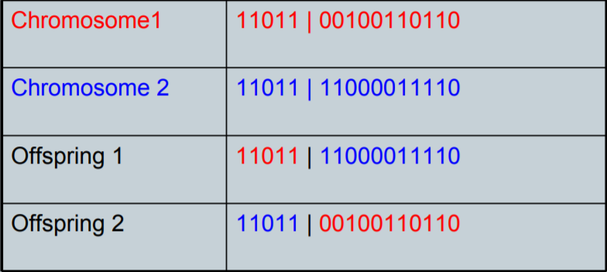

**Two-Point Crossover**- Two random points are chosen on the individual chromosomes (strings) and the genetic material is exchanged at these points.

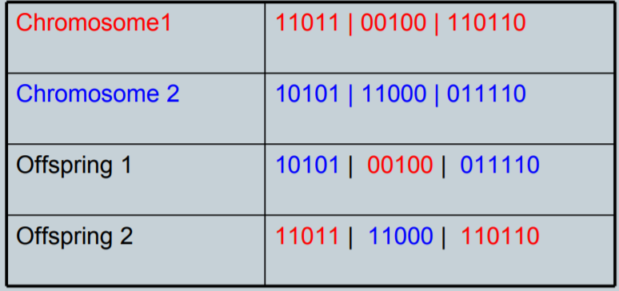

NOTE: These chromosomes are different from the last example

**Uniform Crossover**- Each gene (bit) is selected randomly from one of the corresponding genes of the parent chromosomes.

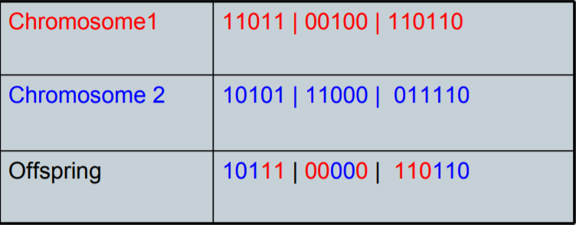

NOTE: Uniform Crossover yields ONLY 1 offspring.

**Mutation:**

It is the process by which a string is deliberately changed so as to maintain diversity in the population set. For chromosomes using Binary Encoding, randomly selected bits are inverted.

